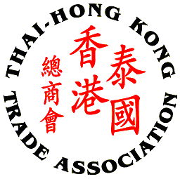
Thai – Hong Kong Trade Association

GET TOGETHER PARTY 2015

SPONSORSHIP FORM

Please complete this form and return to THTA at 02 343 9029
By Friday, 12th June 2015

Company/Sponsor Name: ___________________________________________________
Company Address: _________________________________________________________
_________________________________________________________________________
Contact Person’s Name: ___________________________ Position: ________________
Tel No.: ________________ Fax No.: ________________ Email: __________________

Sponsorship Packages: (Please tick √ one of the following)

□ Sponsorship package for Lucky draw prizes (Details of contribution other than cash)
_________________________________________________________________________

_________________________________________________________________________

- Company name/logo prominently displayed on the e-invitation and the event
- Company name on all correspondence / Thank you letters
Recognition of contribution on website

***For your kind sponsorship, please attached your high resolution company logo file to displayed on the event***

